Text file: It is a kind of computer file that is structured as a sequence of lines of text.

It is used for storing and transfering of data.

A file in the .TXT format contains little to no formatting (e.g., no bolding or Italics).

Delimiters used are comma(csv),Tab separated,Pipe separated.

Test case :

1. Check for file Name and file type

2. Validate header and footer

3. Check if the file is right size

4. Check for encryption

5. Check if the number of records are correct

6. Treatment of special characters

7. Check if right character is placed at right fields

8. Check for the right delimiter required

9. Check alignment between records

10. Validate column skew

11. Check if not null is not null

12. Check if primary key has duplicate values

13. Expression

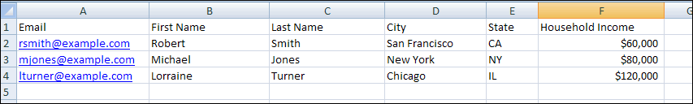

Here is the My Current Database file saved as a .TXT file:

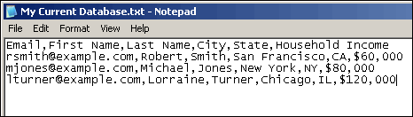

As you can see, the end result of saving as a CSV or TXT file is similar.

**To convert a Word table to the delimited format**

1.    In Word, select the table.

2.    On the **Table** menu, point to **Convert**, and then click **Table to text**.

3.    Click the type of delimiter you want.

**To save a Word file in TXT format**

1.    On the **File**menu, click **Save As**.

2.    Click the **Save as type** box, and then select **Text Only (*.txt)**.

3.    In the **File name** box, type a name, and then click **Save**.

**To change a field name in Access**

Go to Design View, and then change the field names you want.

**To save an Access file in TXT format**

1.    On the **File**menu, click **Export**.

2.    Navigate to the folder you want to save your file in.

3.    Click the **Save as type** box, and then select **Text Files (*.txt, *.csv, *.tab, *.asc)**.”

4.    In the **File name** box, type the name you want. For the file extension, type "txt."

5.    Click the**Save All** button.

6.    In the **Export Text Wizard** dialog, select **Delimited**, and then click **Next**.

7.    Under **Choose the delimiter that separates your fields**, click the delimiter you want.

8.    Click **Include Field Names on First Row**, and then click **Finish**.

9.    Click **Ok**.